Given an m x n matrix, return *all elements of the* matrix *in spiral order*.

**Example 1:**

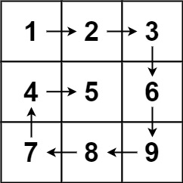

**Input:** matrix = [[1,2,3],[4,5,6],[7,8,9]]

**Output:** [1,2,3,6,9,8,7,4,5]

**Example 2:**

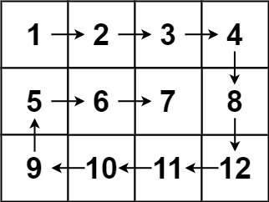

**Input:** matrix = [[1,2,3,4],[5,6,7,8],[9,10,11,12]]

**Output:** [1,2,3,4,8,12,11,10,9,5,6,7]

**Constraints:**

* m == matrix.length
* n == matrix[i].length
* 1 <= m, n <= 10
* -100 <= matrix[i][j] <= 100